Setup GIT

Go to file explorer then go to c:/

Create a folder and name whatever you want!

In the command prompt, type c/

Then ls for the list of files.

Kung nandun yung folder na ginawa mo, type cd <folder-created>/

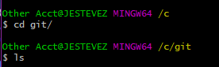

Since, walang laman yung folder nacreate mo, sundin yung nasa litrato below.

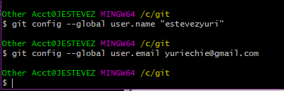

Go to browser first then Kung nasa github tab ka, hanapin mo yung clone or download then kopyahin mo yung URL. Go back to the command prompt, type git + clone + <paste the URL>

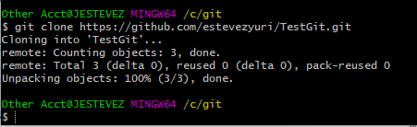

Go to file explorer tapos go to git folder. Nandyan na yung repository na ginawa mo

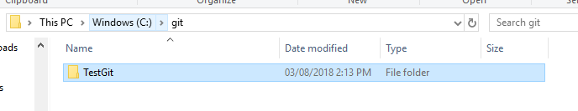

Ayan na yung read me….

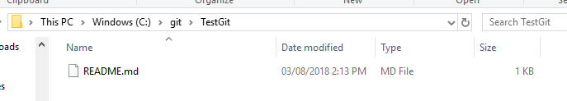

Eh sysad ka ateng kaya ganto gawin mo!

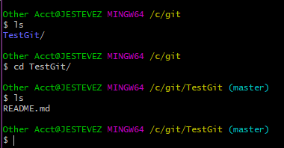

Para maiadd mo yung text file sag it hub, ganto gawin mo: in your TestGit folder, add a text document tas create ka ng text dyan sa file mo … tapos sundin mon a yung nasa picture …

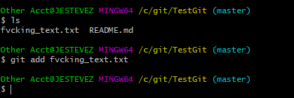

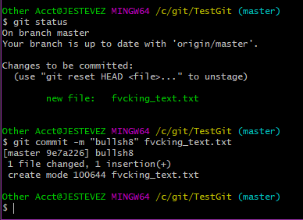

Para magtransfer yung file from PC to github, gawin mo yung command na nasa picture



Tapos login ka

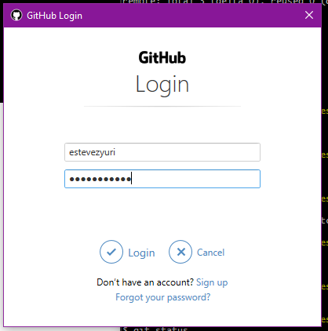

Eto yung resulta

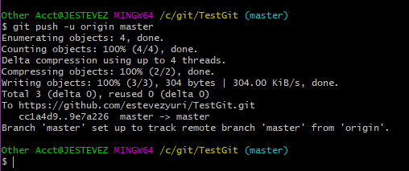

Ganyan ang mangyayari kapag nagrefresh ka ng browser mo, meaning nandyan na yung file na nacreate mo from local disk.

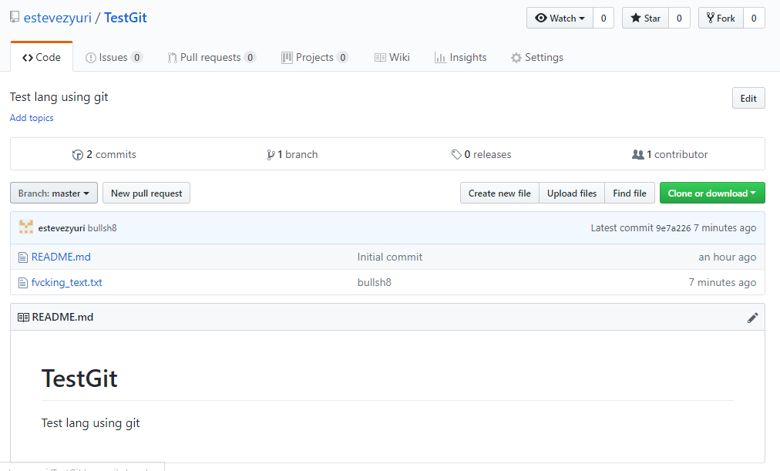

Pero kung nais mong iedit yung file, mag git status muna then commit ka ulit tapos push

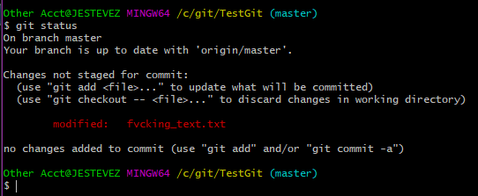

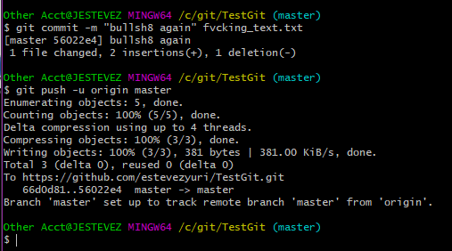

AYAN! Tapos refesh mo browser mo …

